Hankinson Public School

HEALTH & SAFETY
SMART RESTART PLAN

Hankinson Public School Board Approved
August 6, 2020

Hankinson Public School Families,

It has been a challenge for our entire community since March, but we hope you have found ways to cope and embrace this new normal. Thank you to the students, staff, parents, and community members who have helped us succeed in these difficult times. The 2019-2020 school year was challenging but we are proud of students and thankful the district was able to celebrate our seniors’ accomplishments with a graduation exercise.

The challenge now is planning for what school will look like during the 2020-2021 school year. This is a daunting task as we all realize how the impact and response to COVID-19 has changed rapidly over the past four months. This plan will try to address these challenges, while providing a flexible framework to guide our response over the next school year.

For academic, social-emotional, and economic reasons, we are compelled to strive to return to an in-person model. Yet, we cannot disregard that the health and safety concerns associated with the virus remain. The district must consider all practical steps to keep our schools from contributing to virus spread in our community.

We realize that reviewing this plan may not address every question you have. We recognize some concepts and actions may be polarizing, and there are strong opinions about what the school should do or should not. But we must remain open to what is possible and consider all options so we can move forward.

Thank you for your time reviewing this plan. We encourage everyone to ask questions and communicate their concerns as we move forward. Together, our school can provide quality education to our children in a safe manner if we work together to solve problems.

Respectfully,

Chad Benson
Superintendent

Assumptions & Assurances
The Hankinson Public School believes:

- Every student should have the opportunity to engage in learning, regardless of the spread of COVID-19 in our community.
- We have a vital role in providing safe environments for students, focusing on both social-emotional and physical health.
- By working together with educators, staff, health care professionals, parents, students, and community members we can solve most challenges.
- Our district will make decisions based on the most current guidance from local, state, and national health care officials.
- Our School Board will ensure our plan meets the needs of our students, educators, staff, and community.

Our Planning Team

The Hankinson Public School’s Return to Learning Plan was crafted and reviewed by a team consisting of the following List all on your group – below might be some suggested members – you likely may have more:
- Educators  - Custodial Staff  - Parents  - Richland County Health Department  - School Superintendent | - Secretaries  - School Board member  - Students  - School Principals
Input was gathered by various means to allow for a wide range of input, while maintaining social distancing.

COVID-19 Response Team & Coordinators
This organizational structure was crafted to assist in the development and monitoring of the district return to learning plan. This structure identifies leaders and guiding team members that will serve as a voice in how the district responds to COVID-19 during the school year. This plan is designed to address the issues of reopening as well as provide a nimble and responsive process to address issues that may not be recognized today.
INSTRUCTION –Faculty and principals are responsible for providing proper instruction for their classes based on the standards. Depending upon the current situation, the instruction may take multiple of forms. (i.e in-person, blended, virtual)

OPERATIONS –Day to day operations of the school. Custodial staff – ensure the school is properly cleaned. Staff – ensure classrooms are properly arranged and students adhere to classroom and school rules. The school board will provide insight and approval of reentry plans.

COMMUNITY RELATIONS / COMMUNICATION – Covid Committee
- Students
- Parents
- Teachers & Staff
- Administrators
- Board
- Certified Staff

The three components have been identified as key operational teams that consist of multiple departments. Each operational team will work implement the return to learn plan and address challenges as they arise.

COVID-19 Coordinators
The Hankinson Public School will have an identified COVID-19 Coordinator who will be responsible for the health and safety preparedness and response planning. The coordinator will be available to the NDDoH 24 hours a day / 7 days a week to respond to phone calls from public health. This position will assist public health in identifying and notifying close contacts in the school setting. The coordinator will report cases of COVID-19, found in the school setting, to health officials and the State Superintendent of Public Instruction’s office.

Chad Benson, Superintendent will assume the role of COVID-19 Coordinator for the Hankinson Public School District. If Mr. Benson is unable to be reached the secondary contacts will be Anne Biewer (Elementary Principal) and Kent Dennis (High School Principal).

Phases
The following phases will be used to define the community risk level associated with COVID-19 These phases align with the color-coded guidance in the ND Smart Restart Plan. Each level is reported to schools by the NDDoH after rigorous testing and assessment of cases in the community. ND Smart Restart Plan

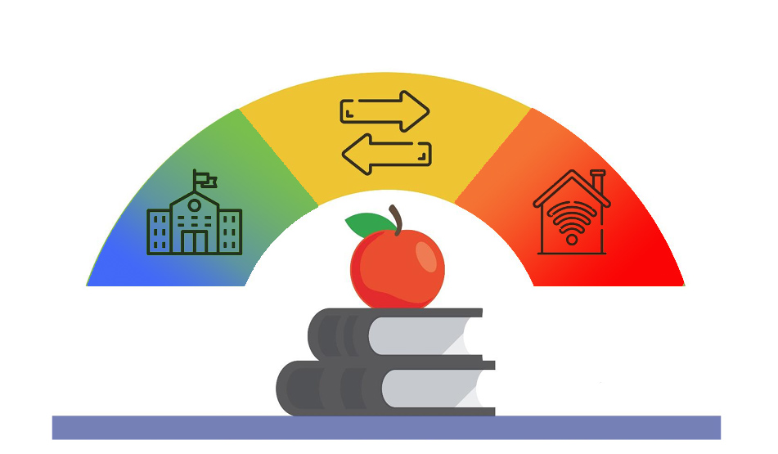
Blue/Green
New normal. Maintain standard precautions
Orange/Red
Significant transmission and high risk of exposure.
Yellow
Heightened expose risk. Transmission is controlled.

Instructional Models
The instructional models used by the district will be guided, in part, by the risk level of COVID-19 in the community as defined within the phases above. This is a guide as instructional models could be altered based on other factors, such as occupancy levels, age of children, and abilities to move certain classes online. Special education services may be provided in-person at school or via social technology.

Traditional Learning
All instruction is delivered in-person with some age level and group modifications. Teachers and students maintain a normal daily schedule. Safety precautions are implemented to enhance staff and student safety.

Blended Learning
Students report to school on a modified schedule. Multiple hybrid models of instructional delivery may be appropriate to meet the educational needs through a variety of delivery models.
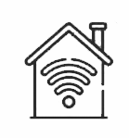 | Distance Learning  All instruction is provided off-campus using distance learning resources or suited to the unique needs of the student. Staff will utilize multiple means of instruction.

Health and Safety Guidance

The district strives to provide a healthy and safe environment for all who occupy our schools. The following guidelines are intended to provide a framework for the district’s response to COVID-19.

Resources
ND Department of Public Instruction
https://www.nd.gov/dpi/parentscommunity/nddpi-updates-and-guidance-covid-19
ND Department of Health
https://www.health.nd.gov/diseases-conditions/coronavirus
Center for Disease Control and Prevention
https://www.cdc.gov/coronavirus/2019-nCoV/index.html

Best Intentions
Despite taking every reasonable precaution, there is no guarantee that our school will be without risk as it relates to COVID-19. The virus will be present on our buses, in our classrooms, and at our activities. In certain situations, social distancing is not possible in a school setting. Our actions, as outlined in this plan, will not prevent any student or staff member from being in contact with the virus.

Protect Yourself and Others

Wash your hands often
- Wash with soap and water for at least 20 seconds especially after blowing your nose, coughing, or sneezing.
- If soap and water are not available, use hand sanitizer that contains at least 60% alcohol.
- Avoid touching your eyes, nose, and mouth with unwashed hands.
- Students are encouraged to wash their hands often throughout the day.

Avoid close contact
- Follow social distancing guidelines when possible.
- Alternate or modified schedules, adjustments to use of common areas, use of outdoor spaces and other actions that increase physical separation may be considered.
- The sharing of instructional materials should be limited as much as possible.
- Physical separation on busing, one student per seat, will be recommended but cannot be guaranteed.
- All visitors who enter the building must have their temperature taken and will be required to wear a mask. When possible, limit visitor access to the building. Examples may include: 1. designated location to meet with salespeople. 2. Parents will not enter the building when dropping off or picking up their students.

Cover coughs and sneezes
- Always cover your mouth and nose with a tissue when you cough or sneeze or use the inside of your elbow.
- Throw tissues away and wash hands or use hand sanitizer to prevent spread.

Clean and disinfect
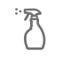
- School staff should clean and disinfect frequently touched surfaces daily.
- Shared materials (not recommended) should be cleaned.
- Classrooms will be cleaned daily by custodial staff.

Cover your mouth and nose with a cloth face cover when around others.
The wearing of masks will be required. There may be times and places where masks may be removed.
- Students will be provided instruction on the proper use of masks.
- Masks are required on all school transportation.

Monitor your health daily
- Be alert for symptoms. Watch for a fever, cough, or shortness of breath.
- Parents are asked to screen their children each day before sending them to school. Use the screening guidance provided (see appendix).
- Staff and students who are sick should stay home.
- Temperatures of symptomatic students or staff may be taken.
  - Symptomatic students may be isolated, and their guardians contacted.

Health & Safety Protocols

Student & Staff Health
Monitoring the health of students and staff will be an important component of a safe and healthy educational environment. Hankinson Public School will take the following measures to ensure all students and staff are healthy while they are at school.

Identifying Students & Staff at Higher Risk
- Back to School and enrollment processes will include questions asking families to identify if their child is at-risk, based on a health professionals’ diagnosis. This information will be provided to the building principal and COVID-19 Coordinator who will contact the family and discuss instructional model options.
- The administration will inquire of all employees if they are at-risk, based on a health professionals’ diagnosis. The school administration will work with the employee to coordinate adjustments to the work schedule or workplace.
- When the NDDoH or the Richland County Health Department informs the district of a student or staff member that is COVID-19 positive, that information will be shared with the administration as allowable within district policy and law.

Isolation & Quarantine
- Definitions (see appendix for more information).
  - Isolation – For people who are already sick from the virus. A prevention strategy used to separate people who are sick with the virus from healthy people.
  - Quarantine – For people who are not sick but have been exposed to the virus. A prevention strategy used to monitor people who were exposed for a period of time.
- Hankinson Public School will follow isolation and quarantine guidelines and directives as set by NDDOH and the Richland County Health Department.

If a student or staff members becomes sick at school (or school event)
- Student
  - Students should notify a staff member.
  - Staff should notify the office.
  - The child may be isolated in a predetermined area.
  - Parent / guardian will be contacted to pick up their child.
- Staff
  - Inform your supervisor immediately.
  - Consult with a health care professional.

Return to School
  - When a student or staff member has been isolated or quarantined as directed by NDDoH or the Richland County Health Department they will be allowed to return to school after being cleared by the NDDoH.

Guidance for Grade Level & School Building Level Closure
This is intended as guidance for COVID-19 Coordinators and school leaders on when to close classrooms, grades, and buildings.
- NDDoH may close the school or district at their discretion.
- The superintendent may shift the mode of learning based on local health conditions.
- If in-person learning is suspended for any length of time, the district will determine which mode of instruction will be utilized.

Facility Accommodations & Protocols
The administration and staff will work to develop protocols and accommodations for the day-to-day operations of the school.

Transportation

Routes
- City Routes may be limited or eliminated.
- Students will be assigned seats.
- Family members may be required to sit together.

Safety & Health
- Masks will be required on all routes.
- Buses will be disinfected on a regular basis.

Operational Guidance
Blue / Green
Priorities: | - Ensure students and staff who are symptomatic stay at home.  - Implement reasonable accommodations to reduce school-wide and community spread.
Districtwide Practices: | - Social distancing where possible and reasonable.  - Bus Routes may be limited or eliminated. Students will be assigned seats. Family members may be required to sit together.  - Buildings routinely cleaned and disinfected according to CDC guidelines. Special focus on high touch/traffic areas.  - Handwashing integrated throughout the day.  - Hand sanitizer available throughout the building.  - Support and train parents on use of technology tools and online curricular resources.
Schools: | - Protective measures will be implemented.  - Some school events, assemblies and gatherings may be changed or cancelled.  - Access to campus may be limited, with new protocols.
Classrooms: | - Students may be issued “technology” and trained on how to access online learning resources including LMS system adopted by school.  - Limited use of shared materials and supplies.  - Desks arranged to allow for cohort groups and social distancing where possible and reasonable.  - Staff and students will be required to wear a face coving. There may be times and places where masks may be removed.
Common Areas: | - Guidelines will be implemented for student movement.  - Schedules may be altered to reduce cohorts passing in common areas.  - Lunch times and location may be altered to reduce the number of students in the cafeteria at any one time.
Extracurricular& Activities: | - Guidance and directives from the NDHSAA and other governing boards will be used to guide these activities.
Communications: | - Share information about how to stop the spread of COVID-19.

Yellow
Priorities: | - Ensure students and staff who are symptomatic stay at home.  - Maximize social distancing cohort where possible.  - Support blended learning model.
Districtwide Practices: | - Based on identified COVID cases of students and staff targeted closures may be implemented (class, grade, department, etc).  - Social distancing where possible and reasonable.  - Bus Routes may be limited or eliminated. Students will be assigned seats. Family members may be required to sit together.  - Buildings routinely cleaned and disinfected according to CDC guidelines. Special focus on high touch/traffic areas.  - Handwashing integrated throughout the day.  - Hand sanitizer available throughout each building.  - Support and train parents on use of technology tools and online curricular resources.  - Provide technology support.  - The school will work to assist in providing options for internet access.
Schools: | - Protective measures will be maintained in office spaces.  - Some school events, assemblies and gatherings may be changed or cancelled.  - Access to campus may be additionally limited, with new protocols.
Classrooms: | - Students may be attending school on a hybrid schedule.  - Students will be expected to engage in learning opportunities online using district LMS system on days they are not in school.  - Teachers are expected to make direct student/family contact.  - Limited use of shared materials and supplies when students are in school.  - Desks arranged to allow for cohort groups and social distancing where possible and reasonable.  - Staff and students will be required to wear a face coving. There may be times and places where masks may be removed.
Common Areas: | - Guidelines will be implemented for student movement.  - Schedules might be altered to reduce cohorts passing in common areas.  - Lunch times and locations and how they may be altered to reduce the number of students in the cafeteria at any one time
Extracurricular& Activities: | - Guidance and directives from the NDHSAA and other governing boards will be used to guide these activities.
Communications: | - Share information about how to stop the spread of COVID-19.  - Share technology support resources for parents.

Orange / Red
Priorities: | - Reduce the risk of community spread by closing schools. (Shifting to Distance Learning)
Districtwide Practices: | - Online instruction will be used district wide in all courses at all grade levels.  - Instruction will focus on essential learning targets.  - Attendance and academic progress will be expected.  - Grading policies will not be suspended.  - The school will work to assist in providing options for internet access.  - Local food distribution may be implemented by food service program.
Schools: | - Closed to the public except by special arrangement with the district office.  - Small group meetings or instruction may be allowed, particularly for special needs students or academic interventions.
Classrooms: | - Students will engage in distance learning.  - Students are expected to engage in learning opportunities online (whatever your LMS system).  - Teachers are expected to make direct student/family contact.
Extracurricular& Activities: | - Guidance and directives from the NDHSAA and other governing boards will be used to guide these activities.  - Athletic and other extra/co-curricular activities likely suspended.
Communications: | - Clear communication about academic expectations and grading shared with students and families.  - Share technology support resources for parents.

BEFORE
SCHOOL!

Parents are asked to review this daily health checklist by answering these questions before sending their child to school.
(Parents do not need to send the questionnaire to school)

Has your child had close contact with a confirmed case of COVID-19 in the past 14 days?
Yes____ No____

Does your child have a new or worsening shortness of breath?
Yes____ No____

Does your child have new or worsening cough?
Yes____ No____

Does your child have a fever of 100.4 or greater?
Yes____ No____

Does your child have chills?
Yes____ No____

Does your child have a sore throat?
Yes____ No____

Does your child have a new loss of taste or smell?
Yes____ No____

If YES to any of the questions STOP!

Do not send your child to school. Contact your healthcare provider. Contact your child’s school to inform them of your child’s absence.
If you can answer NO to all questions, go to school.

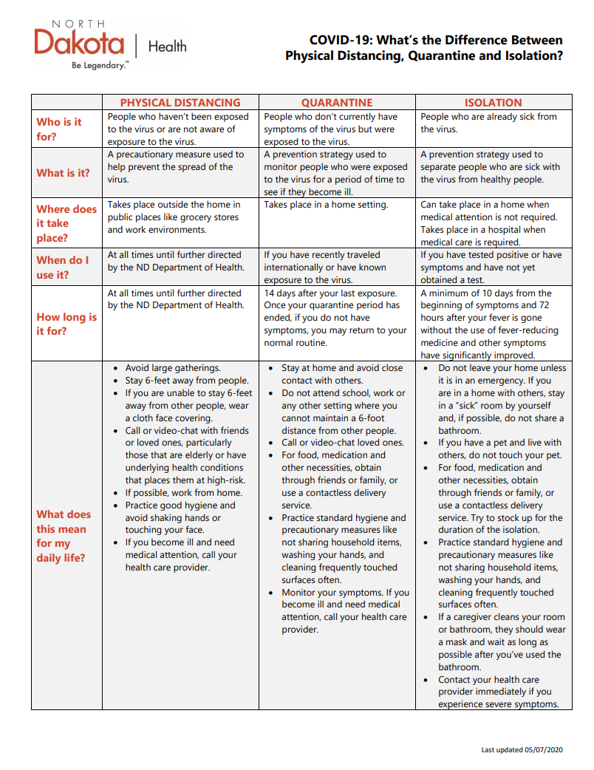

THIS WILL BE INCLUDED IN LETTERS HOME.

Students who choose to receive distance education will be required to use this format through the entire semester. *Administrative approval will be needed to change mid-semester based on extenuating circumstances.

